**2) What are the different steps in grouping fields and combining tables in tableau ? Explain**

**with examples. (With the help of an example create one in tableau)**

**Grouping Fields:**

**Step 1:** **Open your Tableau worksheet.**

**Step 2: Connect to your data source.**

**Step 3: Drag the necessary dimensions and measures to the view.**

**Step 4: Select the fields you want to group:**

* Click and drag to select multiple fields in the Data pane.
* Right-click on the selected fields.
* Choose "Create" and then select "Group."

**Step 5: Define your groups:**

* In the "Create Group" dialog box, Tableau will suggest initial groups based on the values in your selected fields.
* You can adjust these groups or create new ones by selecting and dragging the items.

**Step 6: Name your groups:**

* Provide a meaningful name for your groups.

**Step 7: Click OK:**

* Click OK to apply the grouping.

**Step 8: Use the grouped field:**

* The grouped field appears in the Dimensions pane, and you can use it in your view just like any other dimension.

**Step 9: Modify groups if needed:**

* You can always modify your groups by right-clicking on the grouped field in the Data pane and selecting "Edit Group."

**Combining Tables (Joining Tables):**

**Step 1: Open your Tableau worksheet.**

**Step 2: Connect to your data source.**

**Step 3: Drag the necessary fields to the view.**

**Step 4: Identify the common fields:**

* Determine the fields that exist in both tables that can be used as a basis for combining.

**Step 5: Drag and drop to join tables:**

* Drag a field from one table and drop it onto the corresponding field in the other table. Tableau will automatically try to match the fields.

**Step 6: Choose the join type:**

* Tableau will display a dialog box to confirm the join type (e.g., inner join, left join, etc.).
* Choose the appropriate join type based on your analysis needs.

**Step 7: Click OK:**

* Click OK to apply the join.

**Step 8: Use the combined data:**

* Once the tables are joined, you can use the combined fields in your worksheet.

**Step 9: Adjust join criteria if needed:**

* You can adjust the join criteria by clicking on the join icon in the Data pane and modifying the join clauses.

**Step 10: Resolve any data model issues:**

* If there are data model issues, Tableau will provide suggestions or allow you to manually address them.

**In Tableau:**

**Prerequisites**: Superstore Data-source provided by Tableau, which includes three tables: orders, people, and returns.

**Orders Table**:

Columns: Order ID, Order Date, Ship Date, Ship Mode, Customer Name, Segment, Country/Region, City, State, Province, Category

**People Table**:

Columns: Regional Manager

**Returns Table**:

Columns: Returned

* + - * Select Sales Measure and drag it to columns.
      * Select State dimension and drag it to rows, apply filter and select only USA.
      * You will see a chart with sales data across all states in the USA.

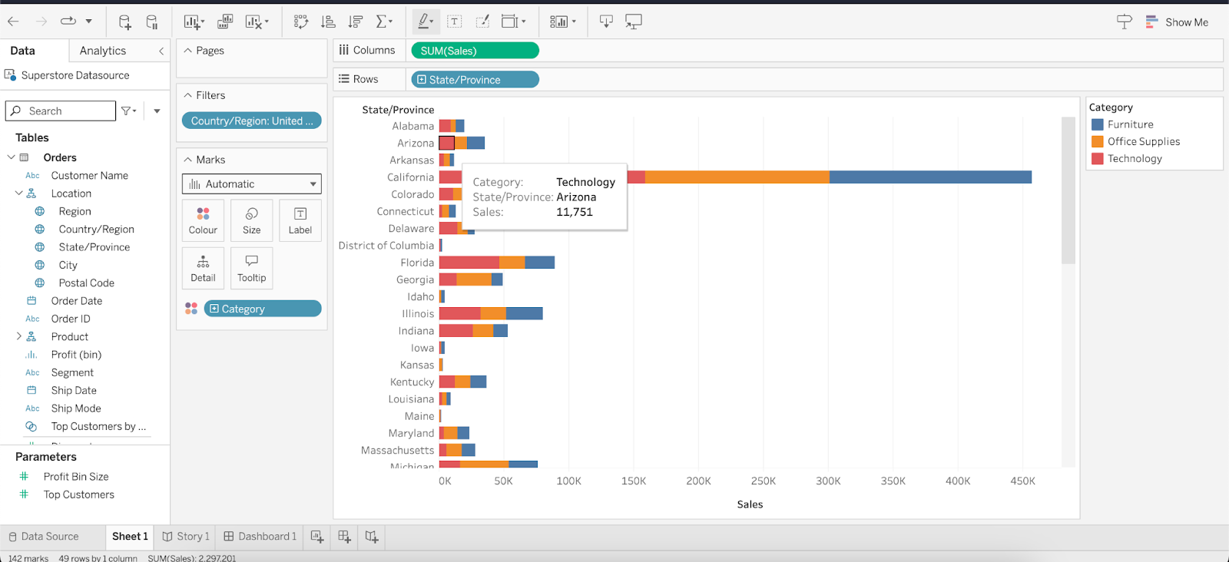

* Now Ctrl + Click on the states you want to group and right-click on the selected states.

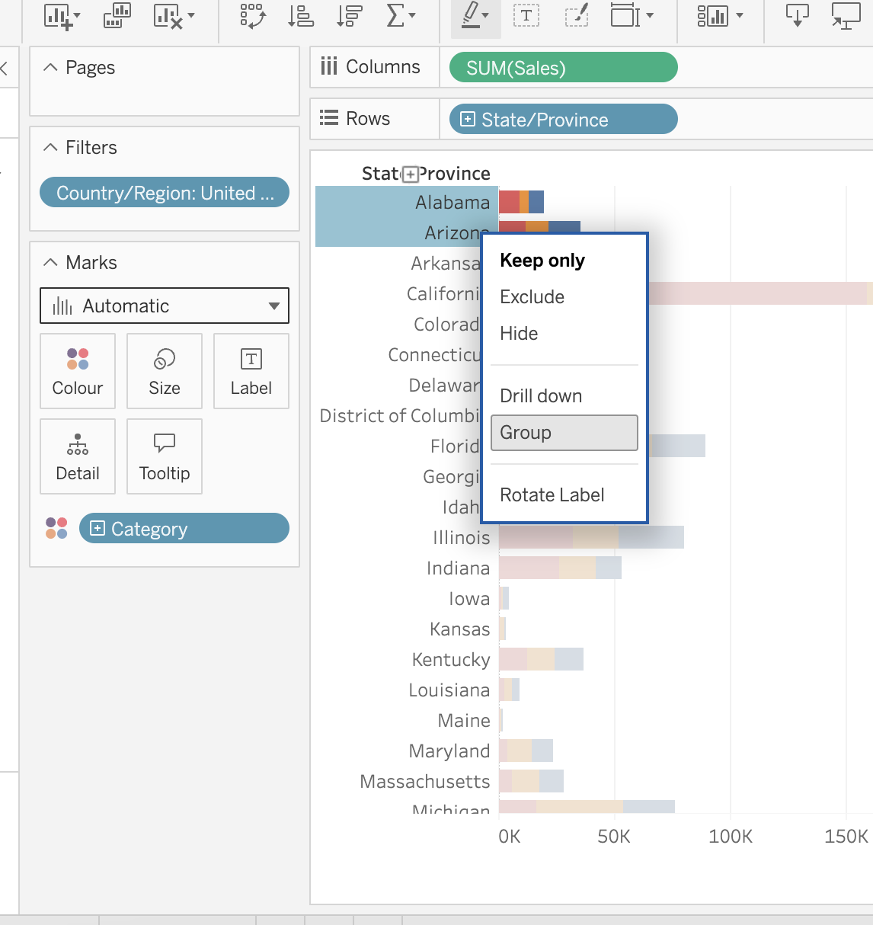

* This creates grouped dimension values which will also be stored in the dimension list.

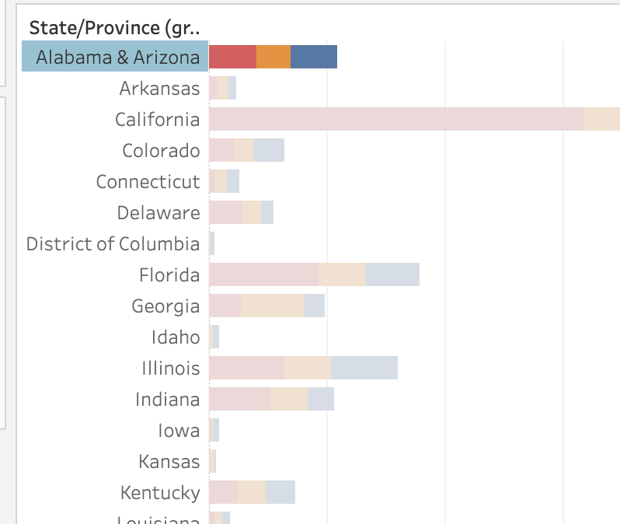

* Similarly, select a two dimension value and right click and select the combined field.